#JustCall211 - Help keep Edmontonians safe

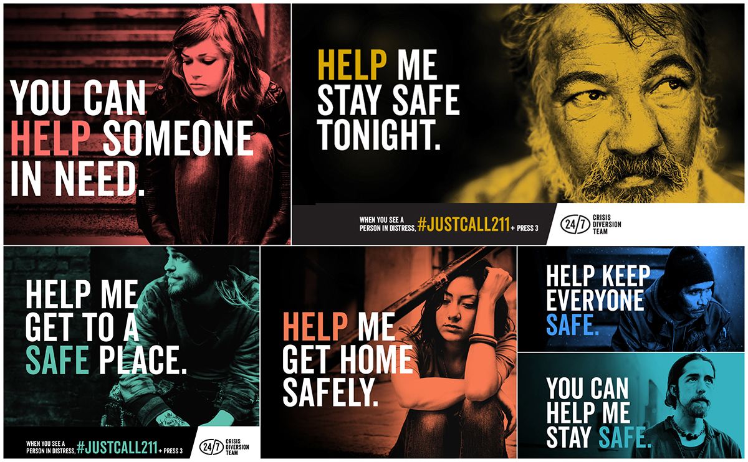

If you’re in Edmonton and you see someone in distress, you can help before police or emergency services are needed by calling 211 and pressing 3 for the 24/7 Crisis Diversion Team.

The 24/7 Crisis Diversion Team responds around-the-clock, seven days a week, 365 days a year to people in distress on the streets of Edmonton by helping people get to a safe place.

24/7 Crisis Diversion is a collaborative partnership of six Edmonton organizations including Boyle Street Community Services, Hope Mission, Canadian Mental Health Association (211), Edmonton Police Service, Alberta Health Services Emergency Medical Services and REACH Edmonton.

The partnership worked with Calder Bateman to create the #JustCall211 social media campaign which launched on November 1, 2016. Within the first 24 hours of launch, the campaign reached 98,585 people. Between November 1 and December 31, 2016, the campaign reached more than 436,000 people.

The campaign was designed to create awareness of the available supports and how everyone can help in non-emergency/non-violent crisis situations. #JustCall211 is a call to action, a way for all Edmontonians to participate in the safety of their community.

Since the launch of the campaign, public calls to the 24/7 Crisis Diversion Team increased by 27 per cent.

In May 2017, #JustCall211 was awarded the IABC Award of Excellence in the Communication Management division for the Social Media Programs category.

Unsure of what a non-emergency crisis is? Download this handy FAQ

24/7 Crisis Diversion Videos:
- #JustCall211 (https://www.youtube.com/watch?v=rXEiXRN_1go&t=42s)
- #JustCall211 (Business Scenario) (https://www.youtube.com/watch?v=DejGwLTsinc)
- #JustCall211 (Ride Along) (https://www.youtube.com/watch?v=mMLKKi4z-zo&t=120s)

TAGS: #JustCall211; Edmonton; Crime Prevention; Community Safety; Prevention; Crisis Diversion; 24/7 Crisis Diversion Teams; REACH Edmonton; Hope Mission; Boyle Street Community Services; Canadian Mental Health Association; 211; Edmonton Police Service; Alberta Health Services Emergency Medical Services

